WHITE BOX TESTING – ONLINE BOOK STORE SYSTEM

1. Statement Coverage

Function: User/Admin Login()

TC-WB-01 Valid Login
Input
- Email = admin@gmail.com
- Password = Admin123
Covers
- Input statements
- Credential verification
- Dashboard redirect
- Success message
Expected Result
- Login successful
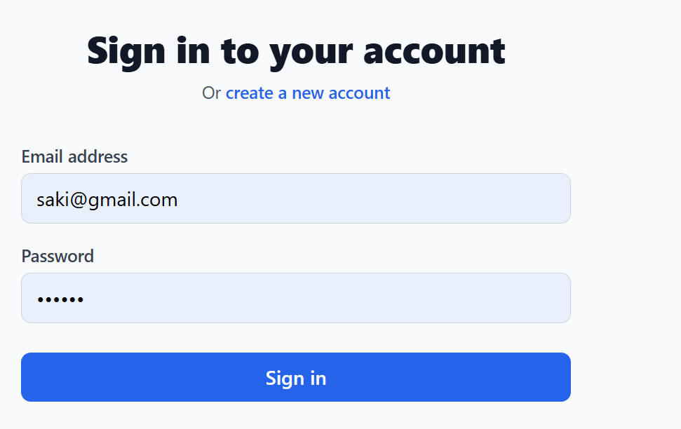

TC-WB-02 Invalid Login
Input
- Email = admin@gmail.com
- Password = wrong123
Covers
- Input statements
- Validation statements
- Error message
Expected Result
- Login failed
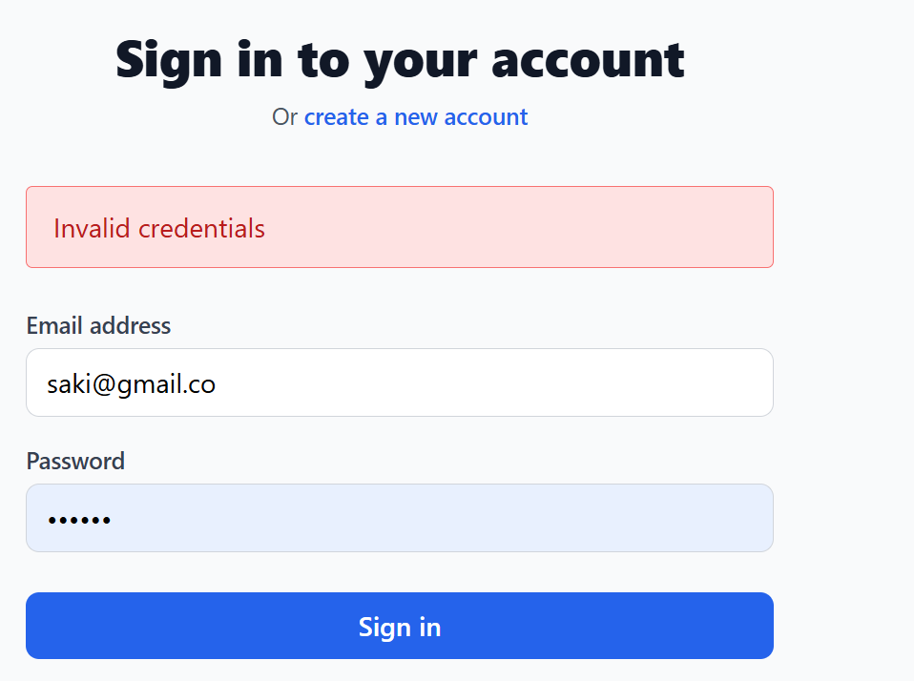

Function: AddBook()

TC-WB-03 Valid Book Entry
Input
- Title = C++ Programming
- Author = Bjarne
- Category = Friction
- PDF Uploaded
Covers
- Field validation
- Database insertion
- Success message
Expected Result
- Book added
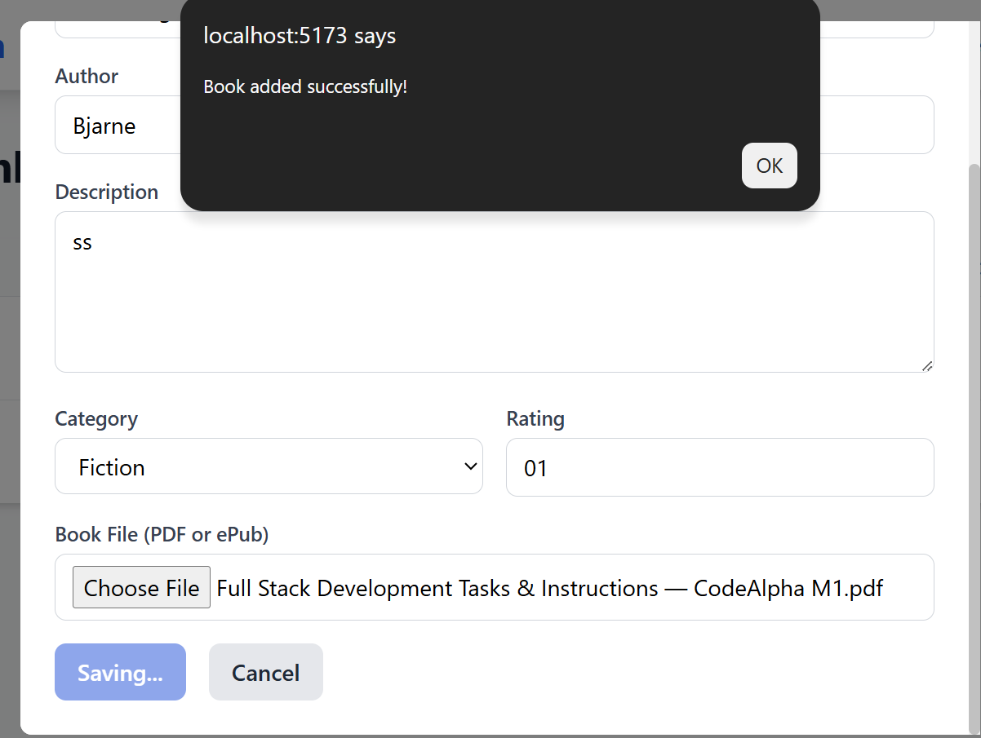

TC-WB-04 Missing PDF
Input
- PDF = NULL
Covers
- PDF validation statement
- Error handling statement
Expected Result
- Upload rejected
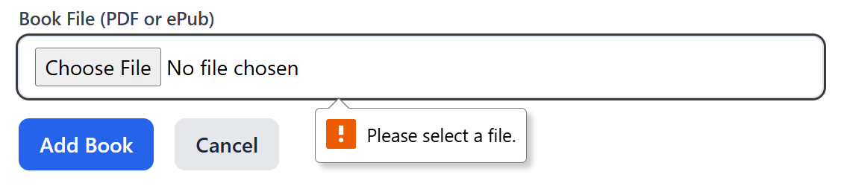

2. Branch Coverage

Login Function
Condition:
if(email == storedEmail && password == storedPassword)
TC ID | Email | Password | Branch
BC-01 | Correct | Correct | TRUE
BC-02 | Wrong | Correct | FALSE
BC-03 | Correct | Wrong | FALSE
BC-04 | Wrong | Wrong | FALSE



Add Book Function
Condition:
if(pdfUploaded)
TC ID | PDF Status | Branch
BC-05 | Uploaded | TRUE
BC-06 | Missing | FALSE



Download Book
Condition:
if(bookExists)
TC ID | Book | Branch
BC-07 | Existing Book | TRUE
BC-08 | Invalid Book ID | FALSE



Favorite Function
Condition:
if(!alreadyFavorite)
TC ID | Status | Branch
BC-09 | New Favorite | TRUE
BC-10 | Duplicate Favorite | F  ALSE

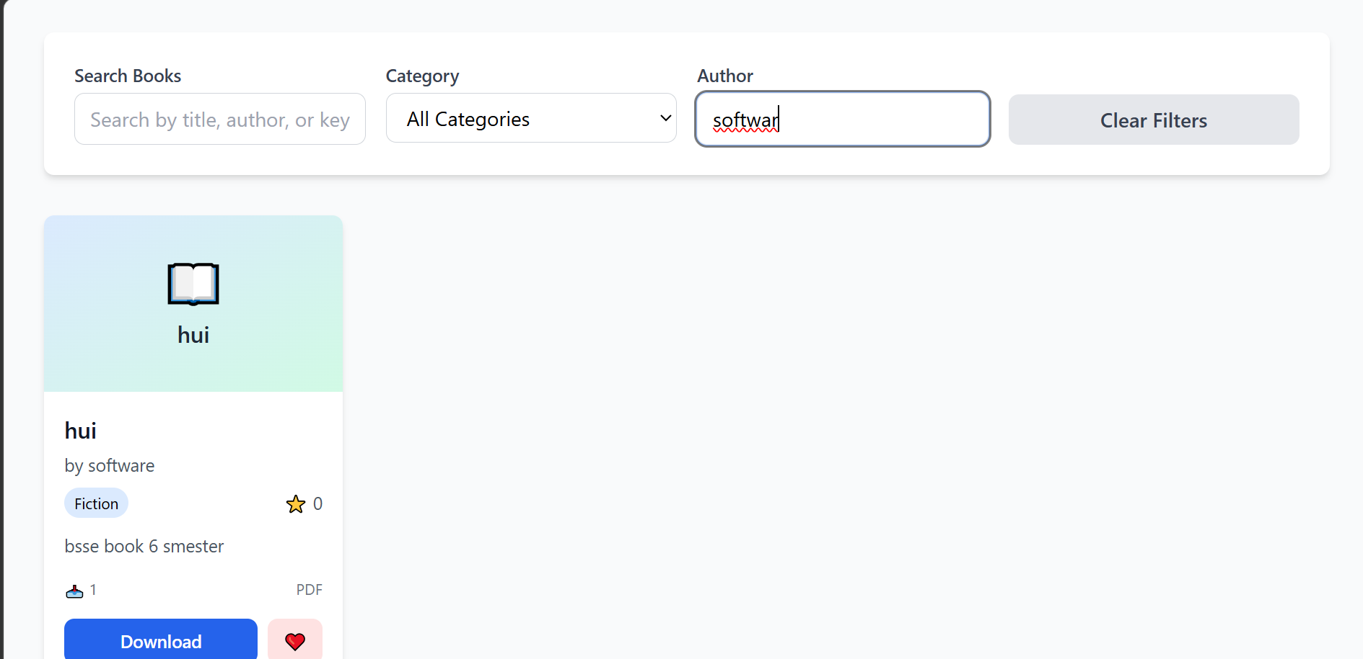

3. Condition Coverage

Signup Validation
Condition:
if(password.length() >= 6)
TC ID | Password | Result
CC-01 | Pass1234 | TRUE
CC-02 | Pass12 | FALSE

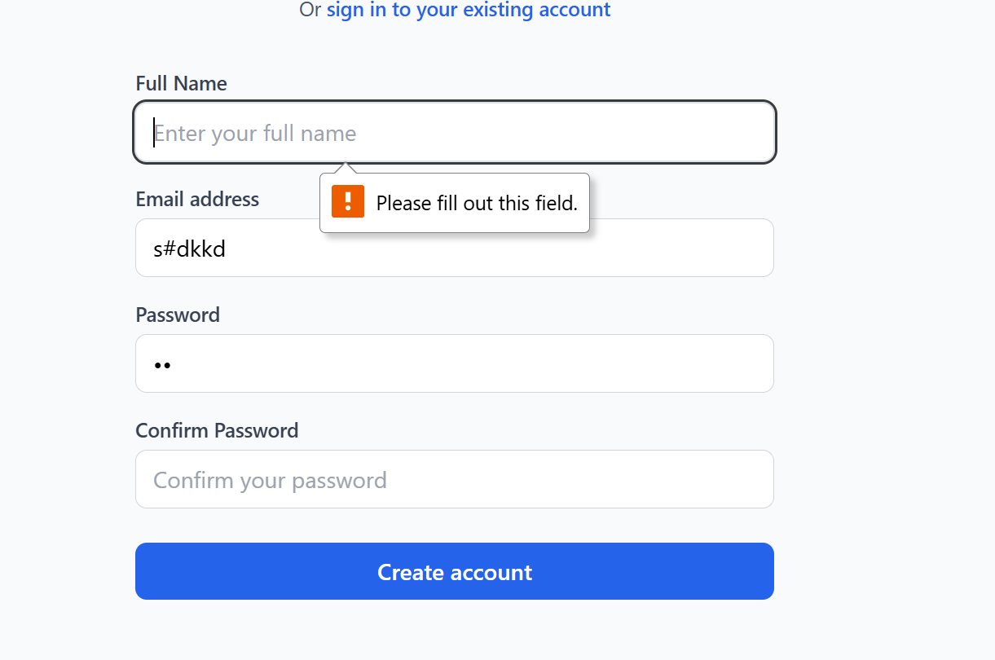

Pages Validation
Condition:
if(pages > 0)
TC ID | Pages | Result
CC-06 | 350 | TRUE
CC-07 | 0 | FALSE

4. Loop Testing

Search Book Loop
Function:
for(book in books)
TC ID | Books Found | Iterations | Expected Result
LT-01 | 0 | 0 | No Results
LT-02 | 1 | 1 | Single Result
LT-03 | 5 | 5 | Display All
LT-04 | 100 | 100 | Performance Test

Favorite List Loop
Function:
while(favoriteList)
TC ID | Favorites | Expected Result
LT-05 | Empty | No Favorites
LT-06 | 1 Book | Display One
LT-07 | 10 Books | Display All
LT-08 | 100 Books | Stress Test

Download History Loop
TC ID | Records | Expected Result
LT-09 | 0 | Empty History
LT-10 | 20 | Display Records

5. CONTROL FLOW TESTING

Diagram: CFG Diagram.jpg

1. Control Flow Graph (CFG) Components

1.1 Nodes Identification
Node ID | Description
N1 | Home Page
N2 | Main Menu
N3 | User Signup
N4 | User Login
N5 | User Dashboard
N6 | Search Books
N7 | Filter Books
N8 | Download Book
N9 | Add to Favorite
N10 | View Favorites
N11 | Logout
N12 | Admin Signup
N13 | Admin Login
N14 | Admin Dashboard
N15 | Add Book
N16 | Book Validation
N17 | Book Storage (Database)
N18 | View Favorites (Admin)
N19 | Exit

1.2 Control Flow Edges
From Node | To Node | Condition / Decision
N1 → N2 | Application Start | Program launched
N2 → N3 | if(option == Signup User) | User Signup selected
N2 → N12 | if(option == Signup Admin) | Admin Signup selected
N2 → N4 | if(option == User Login) | User Login selected
N2 → N13 | if(option == Admin Login) | Admin Login selected
N4 → N5 | Valid credentials | Login successful
N4 → N4 | Invalid credentials | Retry login
N13 → N14 | Valid credentials | Admin login successful
N13 → N13 | Invalid credentials | Retry login
N5 → N6 | Search selected | Open search page
N6 → N7 | Filter applied | Filter books
N7 → N8 | Book selected | Download book
N7 → N9 | Favorite selected | Add favorite
N9 → N10 | Favorite stored | View favorites
N10 → N11 | Logout selected | Session end
N14 → N15 | Add Book selected | Open Add Book form
N15 → N16 | Submit Book | Validate data
N16 → N17 | Valid book details | Save book
N16 → N15 | Invalid data | Retry form
N14 → N18 | View Favorites selected | Display favorites
N11 → N19 | Logout | Program exit
N14 → N19 | Exit selected | Program exit

2. Independent Execution Paths

P1
N1 → N2 → N3 → N4 → N5 → N6 → N7 → N8 → N11 → N19
User Signup → Login → Search → Download → Logout

P2
N1 → N2 → N3 → N4 → N5 → N6 → N7 → N9 → N10 → N11 → N19
User Signup → Login → Search → Favorite → View Favorite → Logout

P3
N1 → N2 → N12 → N13 → N14 → N15 → N16 → N17 → N19
Admin Signup → Login → Add Book → Save Book

P4
N1 → N2 → N13 → N13 → N14
Admin Invalid Login → Retry → Success Login

P5
N1 → N2 → N4 → N4 → N5
User Invalid Login → Retry → Success Login

P6
N1 → N2 → N13 → N14 → N15 → N16 → N15
Admin Add Book Validation Failure Loop

3. LOOP TESTING ANALYSIS

3.1 Identified Loops
Loop ID | Location | Type
L1 | User Login | Login Retry Loop
L2 | Admin Login | Login Retry Loop
L3 | Search Books | Search Result Loop
L4 | Filter Books | Iteration Loop
L5 | Favorite List | While Loop
L6 | Download History | While Loop
L7 | Add Book Validation | Validation Loop
L8 | User Signup Validation | Input Validation Loop
L9 | Admin Signup Validation | Input Validation Loop

3.2 Loop Testing Cases

L1: User Login Loop
Test Case ID | Input Condition | Expected Output
TC-L1-1 | Wrong Email | Retry Login
TC-L1-2 | Wrong Password | Retry Login
TC-L1-3 | Correct Credentials | Dashboard Open

L2: Admin Login Loop
Test Case ID | Input Condition | Expected Output
TC-L2-1 | Wrong Email | Retry Login
TC-L2-2 | Wrong Password | Retry Login
TC-L2-3 | Correct Credentials | Admin Dashboard

L3: Search Books Loop
Test Case ID | Search Result | Expected Output
TC-L3-1 | No Book Found | No Results
TC-L3-2 | One Book Found | Single Record
TC-L3-3 | Multiple Books Found | Display All Books

L4: Filter Books Loop
Test Case ID | Filter Type | Expected Output
TC-L4-1 | Author Filter | Matching Books
TC-L4-2 | Category Filter | Matching Books
TC-L4-3 | Invalid Filter | No Result

L5: Favorite List Loop
Test Case ID | Favorite Count | Expected Output
TC-L5-1 | Empty List | No Favorites
TC-L5-2 | 1 Favorite | Display One Book
TC-L5-3 | 10 Favorites | Display All Books

L6: Download History Loop
Test Case ID | Download Records | Expected Output
TC-L6-1 | No Downloads | Empty History
TC-L6-2 | One Download | Display Record
TC-L6-3 | Multiple Downloads | Display All Records

L7: Add Book Validation Loop
Test Case ID | Input | Expected Output
TC-L7-1 | Missing Title | Retry Form
TC-L7-2 | Missing PDF | Retry Form
TC-L7-3 | Complete Data | Book Saved

L8: User Signup Validation Loop
Test Case ID | Input | Expected Output
TC-L8-1 | Invalid Email | Retry Input
TC-L8-2 | Weak Password | Retry Input
TC-L8-3 | Valid Data | Account Created

L9: Admin Signup Validation Loop
Test Case ID | Input | Expected Output
TC-L9-1 | Invalid Email | Retry Input
TC-L9-2 | Empty Fields | Retry Input
TC-L9-3 | Valid Data | Admin Account Created

6. Cyclomatic Complexity Analysis
Cyclomatic Complexity (CC) = E - N + 2P
Where:
- E = Number of Edges
- N = Number of Nodes
- P = Number of Connected Components (usually 1)
Alternative Formula:
CC = Number of Decision Points + 1
A higher Cyclomatic Complexity indicates more complex code requiring more test cases. A CC value between 1-10 is considered simple, 11-20 moderate, and above 20 complex.

6.1 Function-wise Cyclomatic Complexity

1. User Signup()
Decision Points:
if(username empty) -> 1
if(email invalid) -> 1
if(password length < 8)
if(user already exists)
CC = 4 + 1 = 5

2. User Login()
Decision Points:
if(email exists) -> 1
if(password correct) -> 1
if(account active) -> 1
CC = 3 + 1 = 4

3. Admin Signup()
Decision Points:
if(username empty) -> 1
if(email invalid) -> 1
if(password valid) -> 1
if(admin already exists) -> 1
CC = 4 + 1 = 5

4. Admin Login()
Decision Points:
if(email exists) -> 1
if(password correct) -> 1
if(admin role verified) -> 1
CC = 3 + 1 = 4

5. Add Book()
Decision Points:
if(title empty) -> 1
if(author empty) -> 1
if(category empty) -> 1
if(year valid) -> 1
if(pdf uploaded) -> 1
CC = 5 + 1 = 6

6. Search Books()
Decision Points:
for(each book) -> 1
if(keyword match) -> 1
if(book found) -> 1
CC = 3 + 1 = 4

7. Filter Books()
Decision Points:
for(each book) -> 1
if(author match) -> 1
if(category match) -> 1
CC = 3 + 1 = 4

8. Download Book()
Decision Points:
if(user logged in) -> 1
if(book exists) -> 1
if(pdf available) -> 1
CC = 3 + 1 = 4

9. Add To Favorite()
Decision Points:
if(user logged in) -> 1
if(book exists) -> 1
if(not already favorite) -> 1
CC = 3 + 1 = 4

10. View Favorites()
Decision Points:
if(favorite list empty) -> 1
for(each favorite book) -> 1
CC = 2 + 1 = 3

11. Logout()
Decision Points:
if(session exists) -> 1
CC = 1 + 1 = 2

12. Main Dashboard/Menu()
Decision Points:
switch(menu option) -> 7
if(admin selected) -> 1
if(user selected) -> 1
while(application running) -> 1
CC = 10 + 1 = 11

6.2 Overall System Complexity
Function | Decision Points | Cyclomatic Complexity (CC) | Risk Level
User Signup() | 4 | 5 | Low
User Login() | 3 | 4 | Low
Admin Signup() | 4 | 5 | Low
Admin Login() | 3 | 4 | Low
Add Book() | 5 | 6 | Moderate
Search Books() | 3 | 4 | Low
Filter Books() | 3 | 4 | Low
Download Book() | 3 | 4 | Low
Add To Favorite() | 3 | 4 | Low
View Favorites() | 2 | 3 | Low
Logout() | 1 | 2 | Low
Main Dashboard/Menu() | 10 | 11 | Moderate

Total Estimated Cyclomatic Complexity
Metric | Value
Total Decision Points | 44
Total Cyclomatic Complexity | 56
Overall Risk Level | Moderate

Complexity Risk Classification
CC Range | Risk Level | Functions
1-5 | Low Risk – Easy Testing | User Signup, User Login, Admin Signup, Admin Login, Search Books, Filter Books, Download Book, Add Favorite, View Favorites, Logout
6-10 | Moderate Risk – Requires Additional Testing | Add Book
11-20 | High Risk – Consider Refactoring | Main Dashboard/Menu
21+ | Very High Risk – Refactor Required | None

